Fop Lab Task 7
Name: Hafiz Mufassir Amjad
CMS ID: 456049
Section: B

TASK 1
#include <iostream>
using namespace std;
int main()
{
int arrOfInts[10];

cout<<"Enter 10 Integers: ";
for (int i = 0; i<10; i++) {
cin>>arrOfInts[i];
}

cout<<"Array is: {";
for (int i = 0; i<10; i++) {
cout<<arrOfInts[i];
if (i == 9)
continue;

cout<<", ";
}
cout<<"}";
return 0;
}
Output
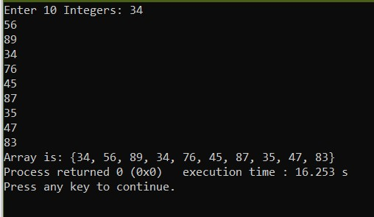
TASK 2
#include <iostream>
using namespace std;
int main()
{
int sum=0, product=1, fiveInts[5] = {34, 65, 12, 17, 72};

for (int i = 0; i<5; i++) {
sum += fiveInts[i];
product *= fiveInts[i];
}
cout<<"Sum is: "<<sum<<endl;
cout<<"Product is: "<<product<<endl;
return 0;
}
Output
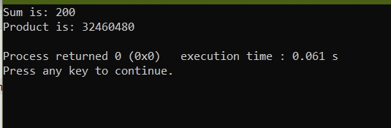
TASK 3
#include <iostream>
using namespace std;

int main()
{
int daSize;
cout<<"Enter the size of diamond (odd number only): ";
cin>>daSize;

if (daSize%2==0) {
cout<<"Please enter an odd number";
return 1;
}
char arr[daSize];

for (int i = 1; i<=daSize; i+=2) {
for (int j = 0; j<daSize; j++)
arr[j] = ' ';
int pos = (daSize-i)/2;
for (int j = pos; j<pos+i; j++)
arr[j] = '*';
for (int j = 0; j<daSize; j++)
cout<<arr[j];
cout<<endl;
}

for (int i = daSize-2; i>=1; i-=2) {
for (int j = 0; j<daSize; j++)
arr[j] = ' ';
int pos = (daSize-i)/2;
for (int j = pos; j<pos+i; j++)
arr[j] = '*';
for (int j = 0; j<daSize; j++)
cout<<arr[j];
cout<<endl;
}
return 0;
}
Output
